Design and implementation Document:

* The C code is for a Blackjack game that is played on a console.
* It has card structures, player structures, and the card deck itself.
* Player cards, totals, and game status are all tracked via global variables.
* There are functions for calculating the player's sum, drawing cards, and initialising and rearranging the deck.
* The main() function sets up the game and gives the player the option to draw cards or end it.
* Blackjack rules are used to decide the game's outcome, which is then shown to the user.

This is how I started my C code and this is for the deck size with valu and cards.

This code emphasysis the name and blance of the game

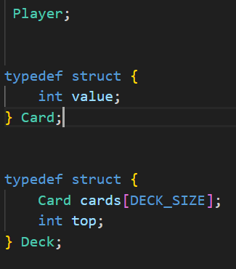

This code defines three structure such as player name and card.

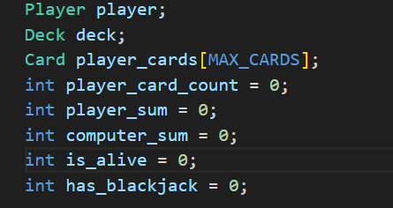

This section I have a player with their name and balance. The player variable represents a player in the game and stores their name and balancxe. The deck it stands for the deck used in the game.

Player_cards[max_cards] this array stores the cards the player holds during the game.

Player_sum this holds the sum of the values of the cards in the players hand.

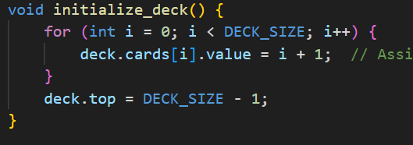

This code defines a function called Initialize deck. That intializes the deck or cards. The code uses a loop to iterate through the cards in the deck.

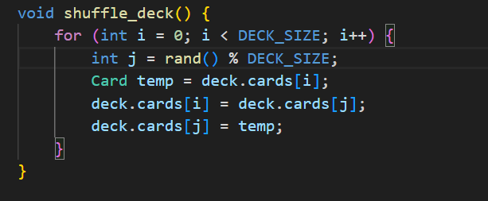

This code defines a function called shuffle deck.

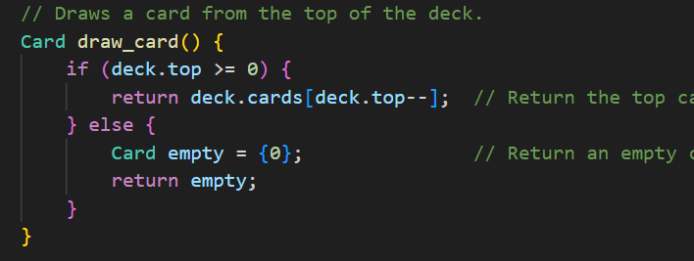

This code draws card that simulates drawing a card from the deck. This code first checks if the deck.top index is greater than or equal to 0.

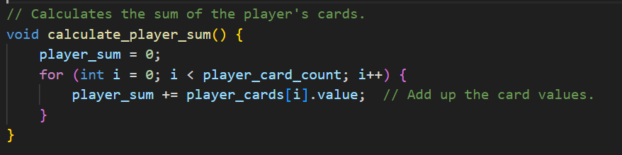

This section of the code calculate players sum. This calculates the sum of the values of players cards.

This section initiates the game. This sets the is_live which is boolean.

This code section is the section that displays the current state of the game. It prints the players name, their cards, and the sum of their card values. It then checks the game status based on the players card sum.

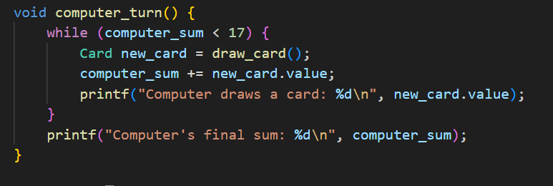

This section is the section of allows the computer to take its turn.

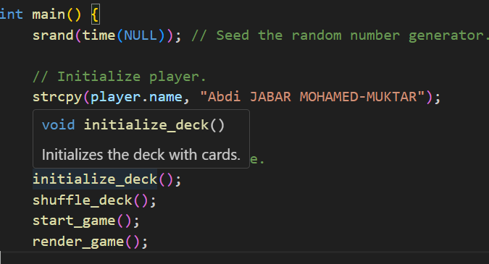

This code is the main function of a program. It initializes a player with the name which is my name and a blance which I made sure its my UNI ID.

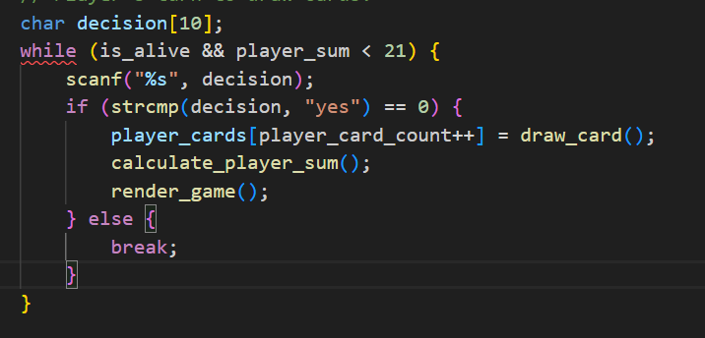

This part of the code is responsible for taking input from the player during yhe game loop.

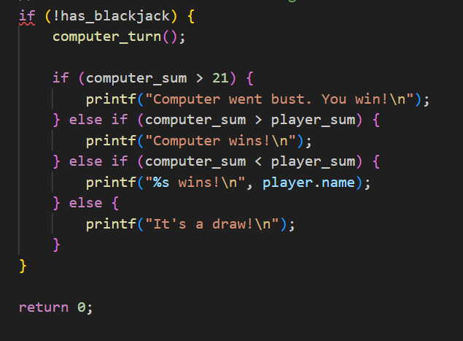

This part of the code is responsible for detemining and displaying the outcome of the game. It checks the players doesn’t have a blackjack, Ift skips if the player has a blackjack. If the player doesn’t have a blackjack it calls the computer_turn.